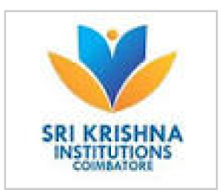 **SRI KRISHNA COLLEGE OF ENGINEERING AND TECHNOLOGY**

**COIMBATORE**

**(An Autonomous Institution)**

**DEPARTMENT OF COMPUTER SCIENCE AND BUSINESS SYSTEMS**

**20CB964- ADVANCED JAVA PROGRAMMING**

**CONTINUOUS ASSESSMENT RECORD**

**Submitted by**

**Name: RAKSHITA T Reg. No: 20eucb034**

**Name: MARKSIM KARKI P Reg. No: 20eucb023**

**Name: AREES MUHMMED S Reg. No: 20eucb008**

**Year & Semester: 111 / V Branch: Computer Science and Business Systems**

**BONAFIDE CERTIFICATE**

**This is to certify that this bonafide record work doneby**

**Mr./Ms. .......Rakshita..T.............................. (Register No.: ......20eucb034..............)**

**Mr./Ms. .....Marksim Karki P..................... (Register No.: .......20eucb023........................) &Mr./Ms. ......Arees Muhmmed S............... (Register No.: ..........20eucb008.....................)**

**during the academic year 2022-2023.**

**Faculty In-Charge HoD**